Project 1: Predicting Used Car Value Retention Ratio Using Multi-Source Data and Machine Learning
Vrutti Patel
CMPSC 455
Janghoon Yang
10/23/2026

Project Description
The goal of this project is to create a machine learning pipeline to forecast the value retention ratio of used cars and find the factors that affect vehicle depreciation. Engineering factors like vehicle age, mileage, manufacturer, model, condition, and more can impact the value of vehicles. In this project, the information on used vehicles was obtained by web scraping them from two online sources: EveryLot and SeeAllCars, both implemented in Python. The data was cleaned, merged, and processed into a single dataset. Original manufacturer suggested retail prices (MSRP) were collected separately and matched with vehicle records to calculate the value retention ratio. The value retention ratio was determined by the ratio of the current listing price to the original MSRP. The higher the ratio, the more the car will hold its value, and the lower the ratio, the more the car will depreciate compared to the original MSRP. Three regression models were implemented: Linear Regression, Random Forest Regression, and Gradient Boosting Regression. Their performances were compared based on Mean Absolute Error (MAE), Root Mean Squared Error (RMSE), and R². The vehicle's features were also examined for their importance to the prediction to see which vehicle attributes made the most significant contribution.

Data collection
The data for the vehicles was gathered from two different online sources, EveryLot and SeeAllCars. The vehicle information was retrieved, extracted and organized using python libraries like Requests, BeautifulSoup, and Pandas. The project was targeted at three car manufacturers: Toyota, Honda, and Ford. For Toyota, the chosen models were Camry, Corolla, and RAV4. The models Honda chose were Civic, Accord, and CR-V. Ford chose to use the F-150, Explorer, and Escape models. The first set of data included 1,050 listings, 500 from EveryLot and 550 from SeeAllCars. The attributes collected were vehicle year, vehicle make, vehicle model, vehicle name, vehicle trim, vehicle body type, vehicle condition, mileage, engine, transmission, drivetrain, fuel type, exterior color, interior color, VIN, listing price, location, listing URL, and source. The VIN and listing URL were especially helpful in determining duplicates and keeping the link between each vehicle and its original listing.
Selected vehicle configurations only were used to collect original MSRP information. MSRP matching considered vehicle year, manufacturer, model, trim, and drivetrain, as the different configurations may have different original prices. There were 29 MSRP configurations in the MSRP database for the last model run, and there were 3 more configurations that were added by the modeling script. These setups were a close match for 117 vehicles listed. A significant obstacle encountered while collecting the data was the availability of vehicle information on two websites. Some listings lacked some trim, engine, drivetrain, exterior, or interior color details. Vehicle names and trims varied from source to source. One difficulty was the ability to obtain accurate historical MSRP since there are multiple trim levels and drivetrains of a single vehicle model with different original price tags. Another difficulty was getting real descriptions of the vehicles. Some listings included vehicle details but lacked a separate seller description. An additional script was created to pull dealership descriptions from pre-existing websites listing URLs when available.

Preprocessing and Integration with discussion
Both datasets were merged into a single dataset using Pandas after gathering the data of the vehicles. The first step was to standardize the vehicle information so that the records from both sources were in the same format. Manufacturer and model names were standardized, and numerical features like mileage and listing price were standardized. The data set was then checked for missing values, duplicated vehicles, wrong prices, and incorrectly categorized models. In the pre-processing stage, 11 vehicles with prices less than $1 000 were excluded as they were unsuitable for analysis. Another 29 models were also dropped due to being part of different model groups, such as Corolla Cross, Camry Solara, Accord Crosstour, and F-150 Lightning. The dataset was preprocessed and resulted in 1010 vehicle listings, among which 474 were from EveryLot, and 536 were from SeeAllCars. The final dataset met the 1000 vehicles minimum, having been preprocessed and duplicates removed. Information on some of the characteristics of the vehicle was missing. Specifically, color of the interior, trim, engine, and location were not always provided in both sources. Categorical values that were missing were addressed during the process of pre-processing and modeling. Inconsistent drivetrain values were also verified by checking records. The modeling pipeline adjusted 98 Corolla/Civic drivetrains based on assumptions of the configuration. These corrections are a limitation since they were not individually compared to the original listing or VIN for each vehicle. The cleaned dataset for vehicles was then joined with the MSRP dataset based on vehicle configuration attributes. There were 1,010 clean vehicles, with 117 of those having a suitable MSRP match and 893 not having a suitable MSRP match. Because the target variable was only calculated if the listing price of the matched vehicle was available, the matched vehicles were included in the regression analysis under supervised regression conditions. This was a substantial decrease in the number of vehicles used for model training and evaluation.

Feature Engineering with discussion
Feature engineering was used to create additional variables that could help the regression models understand patterns in vehicle depreciation. One engineered feature was vehicle age, which was calculated by subtracting the vehicle's model year from 2026. Vehicle age is important because older vehicles generally experience more years of depreciation. Another engineered feature was mileage per year, which represents the approximate amount of driving relative to the vehicle's age. This feature was calculated by dividing total mileage by vehicle age, with appropriate handling for very new vehicles to avoid division by zero. Mileage per year can help distinguish between vehicles with similar total mileage but different ages. The target variable, value retention ratio, was calculated by dividing the current listing price by the original MSRP. For example, if a vehicle originally cost $30,000 and its current listing price was $21,000, its value retention ratio would be 0.70, meaning the vehicle's asking price is 70% of its original MSRP. The project also included a supplementary description extraction process to identify useful information from dealership listing descriptions. Two features were selected: well-maintained and backup-camera mentions. The well-maintained feature identifies whether the dealership description mentions that a vehicle was well-maintained or regularly serviced, while the backup-camera feature identifies whether the description mentions a backup camera or similar equipment. These features were represented using binary values, where 1 indicates that the description contains the relevant claim and 0 indicates that the claim was not detected. After merging the description data with the cleaned vehicle dataset, 515 vehicles had descriptions, including 19 well-maintained mentions and 50 backup-camera mentions. However, only 26 of the 117 MSRP-matched vehicles had descriptions, with 2 well-maintained mentions and 1 backup-camera mention. These features were included in the regression models, but their limited availability reduced their potential influence on prediction performance. The dataset also contained several categorical attributes, including manufacturer, model, trim, body type, drivetrain, fuel type, and transmission. These attributes require encoding because machine learning algorithms generally need numerical inputs. One-hot encoding was used to transform categorical text values into numerical representations, with unknown categories ignored during prediction. This approach also handled high-cardinality attributes such as vehicle trim, although it could increase the number of input features. Numerical attributes were processed using median imputation and standardization, while categorical attributes were processed using missing-value imputation and one-hot encoding. These preprocessing steps were implemented using scikit-learn pipelines to ensure consistent transformations during model training and evaluation.

Model development
Three regression algorithms were trained to predict the vehicle value retention ratio: Linear Regression, Random Forest Regression, and Gradient Boosting Regression. Linear Regression was used as a baseline model because it attempts to predict the target variable by learning a linear relationship between the input features and the value retention ratio. One advantage of Linear Regression is that it is relatively simple and easy to interpret. Linear Regression has one benefit: it is easy to interpret and to create. However, it might not work so well if the relationship between vehicles' features and depreciation is “nonlinear”. Random Forest Regression: Multiple decision trees that are used for prediction. Each tree trains itself from the training data, and the predictions from each tree are aggregated to get the final prediction. Random Forest can model nonlinear relationships and interactions between vehicle features, making it useful for datasets containing different vehicle makes, models, trims, and mileage patterns. Gradient Boosting Regression builds a sequence of decision trees, where each new tree attempts to improve the errors made by the previous trees. This algorithm can learn complex patterns but may be sensitive to training parameters and the amount of available data. The final model dataset contained 117 vehicles with matched MSRP information. The data was divided into training and testing subsets using an 80/20 split, resulting in 93 training samples and 24 testing samples. The split was performed using a random state of 42 to ensure reproducibility. Random Forest was configured with 150 decision trees, while Gradient Boosting and Linear Regression used their default model settings, apart from the specified random state for Gradient Boosting. All three regression models were trained using the training data and evaluated using the testing data. The purpose of comparing these algorithms was to determine which model could most accurately predict the value retention ratio and whether more complex regression methods performed better than a simple linear model.

Evaluation result
The regression models were evaluated using three performance metrics: Mean Absolute Error (MAE), Root Mean Squared Error (RMSE), and R². MAE measures the average absolute difference between predicted and actual values, while RMSE measures prediction error and places greater emphasis on larger mistakes. R² measures how well the model explains variation in the target variable compared with predicting the mean. Lower MAE and RMSE values indicate better prediction performance, while higher R² values generally indicate better explanatory performance. The Linear Regression model achieved an MAE of 0.1573, an RMSE of 0.2760, and an R² of -0.1670. The Random Forest model achieved an MAE of 0.1686, an RMSE of 0.2747, and an R² of -0.1556. The Gradient Boosting model achieved an MAE of 0.1687, an RMSE of 0.2929, and an R² of -0.3144. Based on these results, Random Forest performed best in terms of RMSE and R², while Linear Regression achieved the lowest MAE. Gradient Boosting produced the highest RMSE among the three models. However, all three models produced negative R² values, indicating that none performed better than a simple mean-prediction baseline on the test dataset. One likely reason for the weak performance was the limited number of vehicles with matched MSRP information. Although the cleaned dataset contained 1,010 listings, only 117 vehicles could be used for regression. The models also had to learn patterns across different manufacturers, models, trim levels, and vehicle ages. With only 93 training observations, identifying reliable relationships was difficult, but these limitations suggest that collecting additional verified MSRP values and increasing the number of labeled vehicles could improve future model development.

Depreciation Analysis
Analysis was performed to investigate which vehicle attributes contributed most to the predictions of the best-performing model, Random Forest. Permutation importance was used to estimate how much model performance changed when individual feature values were shuffled. According to the results, vehicle model had the highest importance score of approximately 0.001469, followed by fuel type at 0.000723, body type at 0.000453, mileage per year at 0.000284, and year at 0.000142. Trim had an importance score of approximately 0.000116, while make and description availability had smaller positive importance scores. The two description-based features, well-maintained and backup-camera mentions, had importance scores close to zero. Drivetrain, vehicle age, mileage, and transmission had negative importance scores. These results suggest that model, fuel type, body type, mileage per year, and year were relatively more useful to the current model than the other features. However, the importance scores were very small, and several were negative, indicating that the analysis did not identify strong or reliable predictors on the current test dataset. Vehicle age is generally expected to influence depreciation because vehicles tend to lose value as they become older. However, the current model assigned vehicle age a negative permutation importance score. This does not prove that vehicle age does not affect depreciation. Instead, it indicates that the model did not obtain a reliable predictive benefit from this feature on the limited test dataset. Mileage is another important characteristic when evaluating used vehicles because higher mileage can be associated with greater wear and reduced resale value. In this experiment, mileage and mileage per year did not receive strong positive importance scores. Overall, the results demonstrate the importance of using sufficiently large and representative datasets before concluding the major drivers of depreciation.
- Visualization
Several visualizations were generated to explore the dataset and compare the performance of the regression models. The vehicle price distribution graph shows how listing prices vary across the dataset and helps identify the range of prices and possible outliers. The average price by make graph compares the average listing prices of Toyota, Honda, and Ford vehicles. The mileage versus price scatter plot shows the relationship between vehicle mileage and listing price, with different colors representing each manufacturer. This graph helps examine whether higher mileage is associated with lower listing prices in the collected dataset. The value retention ratio distribution graph shows the variation in retention ratios among the 117 vehicles with matched MSRP information.
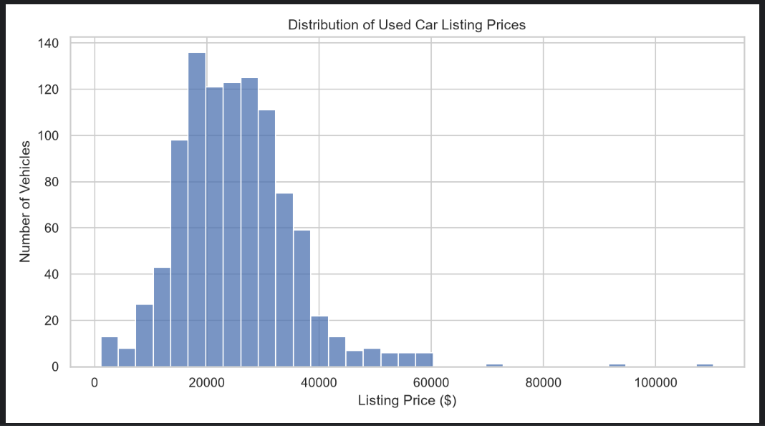
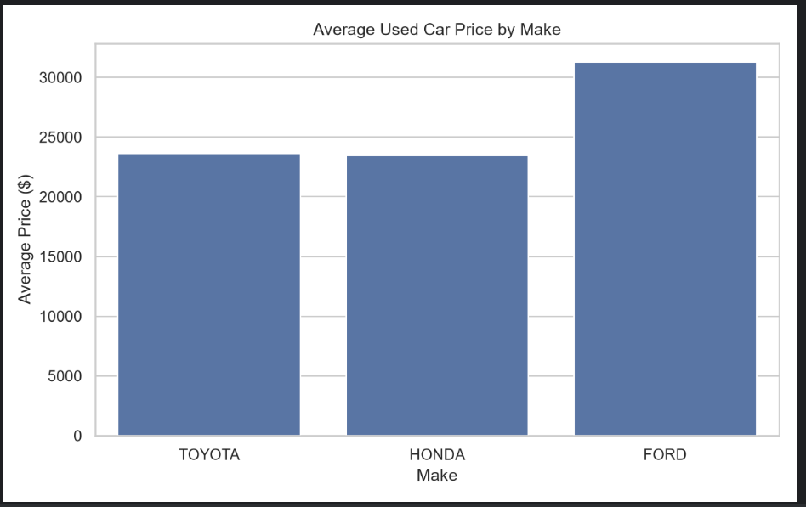
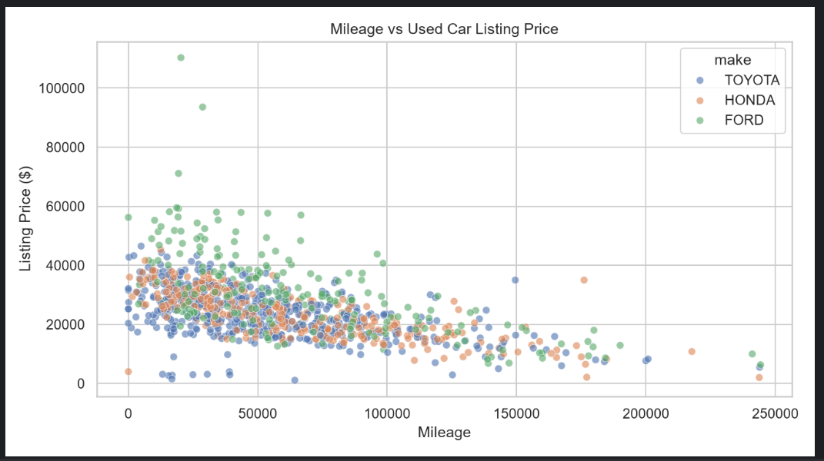
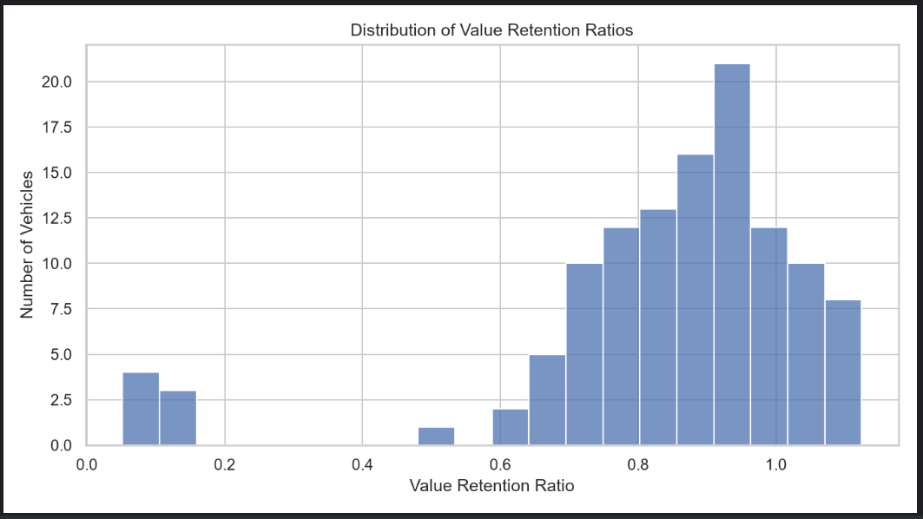
The model comparison visualization presents the RMSE values for Linear Regression, Random Forest, and Gradient Boosting. Random Forest achieved the lowest RMSE of 0.2747, followed closely by Linear Regression at 0.2760. Gradient Boosting had the highest RMSE of 0.2929. The feature importance graph displays the ten highest-ranked features based on permutation importance from the Random Forest model. Vehicle model, fuel type, and body type were among the highest-ranked features, while the two description-based features contributed very little to the model's predictive performance. These visualizations helped compare model performance and understand the limitations of the predictions.
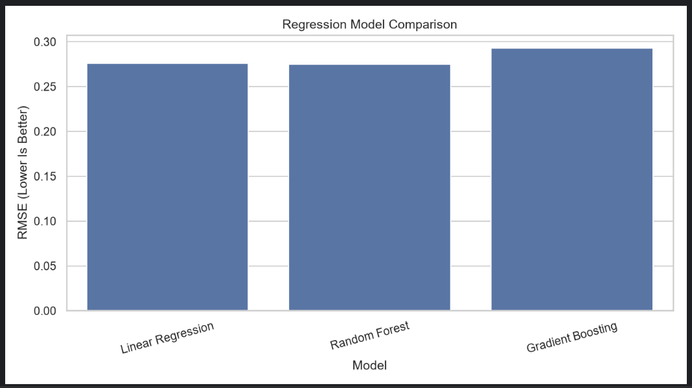
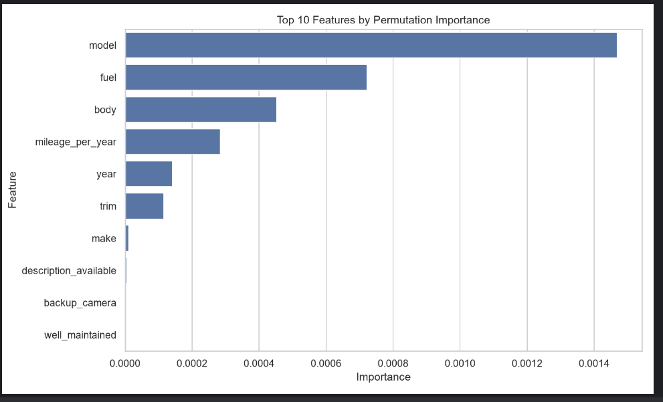

Conclusion
The objective of this project was to predict used vehicle value retention ratios using information collected from multiple online sources. A total of 1,050 vehicle listings were collected from Everylot and SeeAllCars. After preprocessing and integration, the final dataset contained 1,010 vehicles across three manufacturers and nine selected models. Historical MSRP information was collected and matched with eligible vehicles to calculate the value retention ratio. A total of 117 vehicles had suitable MSRP matches and were used for regression modeling. The project also collected dealership descriptions and created two text-based features, well-maintained and backup-camera mentions. After merging the description information, 515 vehicles had descriptions available in the integrated dataset. Three regression algorithms were trained and evaluated, and Random Forest achieved the best performance based on RMSE and R², with an RMSE of 0.2747 and an R² of -0.1556. Linear Regression achieved the lowest MAE of 0.1573. However, all three models produced negative R² values, indicating that the predictions were not sufficiently accurate to outperform a simple mean-prediction baseline. The feature importance analysis suggested that vehicle model, fuel type, and body type were relatively more useful than other features in the current Random Forest model. The description-based features had very low importance scores because very few MSRP-matched vehicles contained those mentions. I had the opportunity to learn more about a machine learning pipeline, from collecting, preprocessing, feature engineering, making a regression model, to evaluating it. I have had experience in collecting and processing real-world data from multiple sources using Python libraries including Requests, Beautiful Soup, Pandas, and Scikit-learn. In addition, I found out that creating a solid dataset is one of the essential components of machine learning. If there are many observations collected, but the target information is missing, this will lead to only a few observations being available for model training. Another essential lesson was that if a model works, that does not necessarily imply that it is accurate. To assess the model performance, various evaluation metrics are required, including MAE, RMSE, and R². Data collection from multiple websites, dealing with missing data, normalizing vehicle configuration, and matching MSRP values from old and new data were the biggest challenges. The different trims and drivetrains made comparisons of MSRs more complicated than originally thought. Many vehicles for sale information did not contain sufficient details to establish the original configuration. Another difficulty was that not all the listing sources included written descriptions of the deals from the dealerships. It was also difficult to train reliable regression models due to the limited number of MSRP-matched vehicles.

AI usage
This project was developed with the use of ChatGPT as an assistance tool. It assisted with understanding programming concepts, debugging Python code, recommending ways to preprocess data and perform feature engineering, and helping to structure the machine learning process. I was having a hard time scraping the data, and the AI helped me a lot.

Reference
Vehicle listing information was collected from Everylot (https://everylot.com) and SeeAllCars (https://seeallcars.com). Historical MSRP information was obtained from the reference URLs recorded in the msrp_verified.csv dataset and the additional MSRP entries included in the modeling script. The project was implemented using Python and libraries including Requests, BeautifulSoup, Pandas, NumPy, Matplotlib, Seaborn, and Scikit-learn. The complete source code, datasets, model results, and generated graphs are included in the project files and GitHub repository.

